**Student Assessment Submission and Declaration**

When submitting evidence for assessment, each student must sign a declaration confirming that the work is their own.

|  |  |  |  |
| --- | --- | --- | --- |
| Student name: | | Assessor name:  **Lana Issa** | |
| Issue date (1St Submission):  **26/12/2023** | Submission date (1St Submission):  **22/1/2024** | | Submitted on: |
| In case of resubmission | | | |
| Issue date (2nd Submission):  25/1/2024 | Submission date (2nd Submission):  27/1/2024 | | Submitted on: |
| Programme: Higher National Diploma in computing – Software Engineering  Higher National Diploma in computing – Cyber Security (Security)  Higher National Diploma in computing – Data Analytics (Artificial Intelligence) | | | |
|  | | | |
| Assignment number and title: 1 implementing and using data structures and algorithms | | | |

Contents

The story of encapsulation 3

What is the benefits of encapsulation and information hiding? 4

discuss the ideas that the need for abstraction in creating classes such as “folder” class, is the founding idea of creating objects? Justify your answer. 6

What is ADT? 7

A comparison table of ADT (Abstract Data Type) & Encapsulation in OOP (Object-Oriented Programming): 9

Clarify what benefits we gain and what drawbacks do we have,if we want to keep the files sorted by ID in an array, so we can easily search through them. 12

Benefits of Sorting Files by ID in an Array: 12

Drawbacks of Sorting Files by ID in an Array: 14

References 16

Plagiarism 16

**The story of encapsulation**

in the world of computer science, during the transformative era of the 1960s and 1970s, a new programming paradigm began to take shape. It was a time when software systems were becoming increasingly complex, and the need for a more effective way to design, manage, and maintain these systems became evident.

In this evolving landscape, a programming language named (Simula emerged) as a pioneer. Developed in the 1960s, Simula introduced groundbreaking concepts of classes and objects, laying the foundation for what would later be known as object-oriented programming (OOP). Simula's innovative ideas provided a way to represent real-world entities as objects in the digital realm.

As the journey continued into the 1970s, a language named Smalltalk entered the stage, expanding on the ideas introduced by Simula. Smalltalk became one of the first true object-oriented programming languages, solidifying the principles of encapsulation, inheritance, and polymorphism.

In the midst of this transformative period, a visionary computer scientist named Alan Kay and his team at Xerox PARC (Palo Alto Research Center Incorporated) were at the forefront of shaping the future of software development. Alan Kay envisioned a world where software would simulate real-world entities through the use of objects and messages.

The concept of encapsulation began to emerge as a fundamental principle of OOP during this time. The idea was simple yet profound—encapsulate data and the methods that operate on that data within a single unit, known as a class. This bundling of related functionalities provided a powerful tool for managing complexity, promoting information hiding, and protecting the internal details of an object.

Encapsulation's influence continued to grow, finding a natural home in modern object-oriented programming languages such as C++, Java, and C#. These languages formalized and standardized the concept, making it an integral part of the OOP paradigm that is widely used in software development today.

And so, the story of encapsulation is a tale of evolution—a collaborative journey driven by the ever-growing complexities of software systems. It is a story that continues to shape the way we design, build, and maintain software in the ever-evolving world of computer science.

**What is the benefits of encapsulation and information hiding?**

**1- Data Protection:**

encapsulation acts as a vigilant guardian, providing a nuanced approach to data protection. Through fine-grained control, encapsulation defines which attributes are private (accessible only within the class) and which are public (open to external access). This meticulous delineation safeguards data from unauthorized access or modification, ensuring the integrity of the program's inner workings. It's akin to a digital lock, where the inner details of an object are shielded, allowing only authorized pathways for interaction. This strategic measure fortifies the core of a program, establishing a disciplined and secure environment for data. Encapsulation is not just a shield; it's a blueprint for constructing a digital vault where the sensitivity of data is paramount.

In the context of a "Folder" class, encapsulation and information hiding act as guardians, protecting sensitive data within the folder. By segregating attributes into private and public scopes, internal details are shielded, ensuring that unauthorized access or modification is prevented. This approach fortifies the security of the folder's contents.

**2- modularity:**

modularity emerges as a guiding principle, bringing order and ease of maintenance to the codebase. When it comes to changes within an object's internal workings, modularity acts as a shield, preventing ripples from spreading through the external code. This intentional isolation ensures that tweaks or enhancements to the internal implementation remain contained, preserving the sanctity of the broader program. The result is a modular and easily maintainable codebase where the impact of modifications is localized, allowing for a more streamlined and efficient approach to code organization.

For the "Folder" class, information hiding serves as a shield during internal changes. Modifications within the folder's structure or behaviour are contained, preventing ripples through external code. This intentional isolation preserves the organization and structure of the folder, facilitating a modular and easily maintainable class.

**3- code organization:**

Encapsulation in code organization is like placing related tools in labeled compartments within a toolbox. By grouping data and behavior logically within classes, it brings order to the code, making it more organized and readable. This modular approach enhances clarity and simplifies both understanding and navigation, fostering an efficient and structured codebase.

Information hiding in the "Folder" class is akin to organizing related tools in labelled compartments. By concealing unnecessary details and exposing only essential interfaces, encapsulation enhances the clarity of the folder's design. This modular approach fosters an efficient and structured "Folder" class, making it organized and readable.

**4- Flexibility and Maintenance:**

Encapsulation, with its emphasis on well-defined interfaces (public methods), allows for changes to the internal implementation without impacting external code. This enhances flexibility, making the codebase more adaptable and easier to maintain. Well-defined interfaces act as a clear contract between internal workings and external interactions, supporting a modular and agile development process. This separation reduces dependencies, simplifying maintenance tasks and facilitating seamless updates over time.

Encapsulation in the "Folder" class enhances flexibility by allowing changes to the internal implementation without affecting external code. Well-defined interfaces, hidden details, and controlled access contribute to streamlined maintenance. Modifications within the folder are localized, ensuring adaptability and ease of maintenance.

**5- Code Reusability:**

encapsulation plays a pivotal role. Objects, encapsulating both data and behavior within classes, become reusable components. The intentional design of classes with encapsulation in mind allows them to seamlessly integrate into different sections of a program or across various projects. This promotes an efficient and widespread reuse of code, fostering a modular and adaptable approach to software development.

The intentional concealment of internal details in the "Folder" class promotes code reusability. The encapsulated folder, encapsulating both data (contents) and behavior, becomes a reusable component. This facilitates the seamless integration of the "Folder" class into different sections of a program or across various projects.

**6- Enhanced Security:**

encapsulation acts as a safeguard by restricting direct access to internal attributes. This intentional control ensures the integrity of data, maintaining the consistency and correctness of an object's state. Through encapsulation, a robust layer of protection is woven into the code, contributing to overall data security and reinforcing the reliability of the software.

Acting as a safeguard, encapsulation in the "Folder" class restricts direct access to internal attributes such as contents. This controlled access ensures the integrity of the folder's contents, maintaining consistency and correctness. Information hiding reinforces the reliability of the "Folder" class, contributing to overall data security.

**7-Polymorphism and Inheritance:**

reuse and flexibility. Encapsulation is a key player in achieving polymorphism, enabling objects of different classes to be treated as objects of a common interface. This synergy, combined with inheritance, forms a powerful trio that facilitates code adaptability, making it easier to extend and modify existing code without disrupting the overall structure. It's a dynamic approach to programming that fosters versatility and supports the evolution of software systems.Encapsulation enables polymorphism by defining a common interface for folders. Information hiding allows for varied implementations of folder behavior without affecting external code. This synergy with inheritance facilitates code adaptability, supporting the creation of diverse folder types within the class.

Top of Form

**discuss the ideas that the need for abstraction in creating classes such as “folder” class, is the founding idea of creating objects? Justify your answer.**

The necessity for abstraction in the creation of classes, exemplified by the "Folder" class, forms the foundational idea behind the concept of creating objects. Abstraction involves the process of simplifying complex systems by modelling classes based on essential characteristics, and this is particularly crucial in object-oriented programming. The "Folder" class, as a representative example, underscores the importance of abstraction in the following nuanced ways:

**Semantic Clarity and Conceptual Precision:**

Abstraction enhances semantic clarity by distilling the intricacies of real-world entities into essential characteristics within the "Folder" class. This not only simplifies the understanding of the class but also ensures conceptual precision. Developers can focus on the fundamental aspects of a folder's functionality, fostering a shared understanding and consistent application of the class.

**Hierarchy and Inheritance:**

Abstraction establishes a hierarchical structure within classes, allowing for the creation of a class hierarchy. In the case of the "Folder" class, abstraction facilitates the representation of common attributes and behaviors shared among various folders. This hierarchical organization supports inheritance, enabling subclasses to inherit and extend the characteristics of a more generalized class. It's a powerful mechanism for code reuse and fostering a structured class hierarchy.

**Dynamic Adaptation to Change:**

The "Folder" class, designed with abstraction, embodies a dynamic approach to adapting to changing requirements. Abstraction allows for the adjustment of essential characteristics without affecting external implementations. This adaptability ensures that the "Folder" class remains robust and relevant over time, accommodating evolving needs without necessitating a complete overhaul of the existing codebase.

**Collaborative Development:**

Abstraction facilitates collaborative development by providing a clear blueprint for the "Folder" class. Developers can collaborate more effectively when working with abstracted classes as they share a common understanding of the class structure. This shared understanding minimizes ambiguities, streamlines development workflows, and contributes to the creation of more cohesive and interoperable software systems.

**Encapsulation of Business Logic:**

Within the "Folder" class, abstraction encapsulates the business logic associated with folders. By selectively exposing essential attributes and behaviors and hiding the implementation details, abstraction ensures that the class serves as a cohesive unit with a well-defined interface. This encapsulation shields the internal workings of the class, promoting a modular design that simplifies both development and maintenance.

**What is ADT?**

Abstract Data Types (ADTs) play a crucial role in organizing and managing the complexity of data structures through the concept of encapsulation. In the realm of ADTs, encapsulation involves bundling both data and the methods that operate on that data into a single unit. This bundling facilitates a clear organization of the structure, enhancing code modularity and maintainability. For instance, a stack ADT encapsulates not only the elements it contains but also the methods like push and pop for manipulating the stack. The encapsulation of both data and operations in ADTs contributes to a more structured and comprehensible approach to handling complex data structures.

ADTs are defined by a set of operations that encapsulate their essential functionality. These operations represent the fundamental actions that users can perform on the data encapsulated by the ADT. By establishing a consistent interface, operations abstract away intricate implementation details, allowing users to interact with the ADT based on functionality rather than internal workings. This abstraction promotes ease of use and simplifies the learning curve for users, creating a standardized way to work with the data structure. The operations within ADTs serve as a bridge between users and the underlying data, emphasizing what actions are possible without delving into how those actions are achieved.

The operations of an ADT not only provide essential functionality but also abstract the mutability or immutability of the data. Operations can be designed to modify the internal state of the ADT (mutating operations) or return a new instance without modifying the existing one (immutable operations). This flexibility allows ADTs to cater to various application requirements, providing options for different usage scenarios. Furthermore, ADT operations encompass error handling mechanisms, specifying the expected behavior in the presence of errors and contributing to the overall robustness of the data structure.

Operational efficiency is a critical consideration in the design of ADTs. Choices made during the design, such as the time complexity of operations, directly impact the performance of the data structure. Balancing ease of use with operational efficiency is essential to creating a well-rounded and effective ADT. Additionally, ADT operations should be designed with interoperability in mind, ensuring seamless integration with other components of the system. Proper documentation, specifying the purpose, expected behavior, and contracts of each operation, guides users in the correct usage of the ADT. Finally, a focus on extensibility, testing, and validation contributes to the reliability and adaptability of ADTs in diverse software applications.

Polymorphism, a key concept in object-oriented programming, is embodied in Abstract Data Types (ADTs) through the ability to use different implementations interchangeably. This flexibility allows developers to switch between various concrete implementations of an ADT without affecting the external code that uses the ADT. Polymorphism promotes code reuse, modularity, and adaptability, making ADTs versatile components in software design.

The concept of inheritance complements ADTs by allowing the creation of specialized ADTs based on existing ones. Inheritance enables the extension of functionality while retaining the core attributes and operations of the parent ADT. For example, a specialized queue ADT with additional features can inherit from the basic queue ADT, promoting code reuse and maintaining a hierarchical structure. This hierarchical organization enhances the clarity of relationships between different ADTs and their variations.

The notion of encapsulation extends beyond individual ADTs to the broader architectural level, where encapsulating multiple ADTs into a cohesive module or package fosters a modular and organized codebase. Encapsulation at the architectural level involves grouping related ADTs, abstracting away internal complexities, and exposing a well-defined interface. This practice enhances code organization, reduces dependencies, and facilitates a modular approach to software development.

Concurrency and parallelism considerations are integral to modern software systems, and ADTs play a role in addressing these challenges. Concurrent data structures, encapsulating synchronization mechanisms and thread-safe operations, allow developers to design scalable and thread-friendly applications. By encapsulating concurrency-related concerns within ADTs, developers can abstract away the complexities of managing shared resources and synchronization, promoting maintainability and correctness in concurrent systems.

**A comparison table of ADT (Abstract Data Type) & Encapsulation in OOP (Object-Oriented Programming):**

|  |  |  |
| --- | --- | --- |
| **Comparison type** | **ADT (Abstract Data Type)** | **Encapsulation in OOP (Object-Oriented Programming):** |
| **Definition:** | An ADT is a high-level description of a set of operations that can be performed on a data structure, abstracting away the implementation details. It focuses on what operations can be performed, not how they are implemented. | Encapsulation is a fundamental concept in OOP that involves bundling data (attributes) and the methods (functions) that operate on that data into a single unit, known as a class. It emphasizes the organization and access control of the internal structure of a class. |
| **Scope:** | ADTs are a broader concept that can be applied in various programming paradigms, not just limited to OOP. | Encapsulation is specific to the OOP paradigm and is a core principle in languages like Java, C++, and Python. |
| **Focus:** | ADTs focus on defining operations and their behavior, without specifying how these operations are implemented. | Encapsulation focuses on bundling data and methods within a class, promoting data hiding and access control. |
| **Implementation Details:** | ADTs abstract away the implementation details, providing a high-level interface. Users of an ADT are concerned with what operations are available, not how they are achieved. | Encapsulation allows for hiding the internal implementation details of a class from the external world. Users interact with the class through a well-defined interface, and the internal details can be changed without affecting the external code. |
| **Language Support:** | ADTs can be implemented in various programming paradigms, including procedural programming. | Encapsulation is a core concept in OOP languages and is an integral part of class-based development. |
| **Relationship** | Encapsulation is a technique used in implementing ADTs to achieve the abstraction of data and operations. | Encapsulation is a broader concept that goes beyond ADTs and is a foundational principle in organizing code in OOP. |
| **Access Control:** | ADTs may not explicitly enforce access control mechanisms, as their focus is on defining operations. | Encapsulation inherently involves access control by specifying the visibility of attributes and methods, allowing for public and private access. |

**the** **Justification of my answer:**

**Justification of Abstraction as the Foundational Idea in Creating Objects, with Emphasis on ADT:**

The foundational idea of creating objects through abstraction, especially within the context of Abstract Data Types (ADTs), is pivotal in shaping the landscape of object-oriented programming. Abstraction acts as a guiding principle, transcending the mere act of simplification, and serves as a cornerstone for bridging the conceptual and practical realms of software development. The significance of abstraction in justifying its role as the foundational idea for creating objects is intricately connected with the principles embodied by ADTs:

**1. Clarity in Design:**

* **Abstraction in ADT:** ADTs inherently embody abstraction by distilling complex data structures into high-level descriptions of operations. This abstraction ensures clarity in the design process by focusing on what operations can be performed rather than dwelling on implementation details. In the creation of the "Folder" class, this clarity manifests as a well-defined set of operations such as adding, removing, and retrieving files.

**2. Maintainability Through Essence:**

* **Abstraction in ADT:** The essence of an object is paramount in ADTs, emphasizing the identification and encapsulation of core characteristics. This focus on essence aligns with the principles of maintainability. For the "Folder" class, this means that modifications or updates are tethered to the core purpose, reducing the risk of unintended consequences and ensuring a streamlined path for maintaining the class over time.

**3. Reusability Across Contexts:**

* **Abstraction in ADT:** ADTs, by their nature, encourage the creation of reusable components. The "Folder" class, designed with abstraction in mind, becomes a versatile building block that seamlessly integrates into various contexts within the software. This reusability aligns with the principles of ADTs, where well-designed abstract structures transcend specific implementations and find utility across different modules or projects.

**4. Alignment with Real-World Concepts:**

* **Abstraction in ADT:** ADTs, including the "Folder" class, aim to align with real-world concepts, abstracting away complexity. The essence of digital folders, such as organization and containment, is distilled into a digital representation. This alignment enhances user understanding, making the software more user-friendly and reflective of familiar experiences.

**5. Adaptability to Evolving Requirements:**

* **Abstraction in ADT:** Abstraction enables the incorporation of new features and changes without compromising existing structures. In the "Folder" class, guided by abstraction, the design accommodates evolving requirements seamlessly. This adaptability is crucial in dynamic software development environments, aligning with the principles of ADTs that emphasize flexibility.

**6. Facilitation of Systematic Development:**

* **Abstraction in ADT:** ADTs encourage a systematic approach to development by focusing on essential aspects. The "Folder" class, shaped by abstraction, is a result of intentional decisions about critical functionality. This systematic development approach enhances efficiency, ensuring that each class contributes meaningfully to the overall architecture, echoing the principles embedded in ADTs.

the justification for abstraction as the foundational idea of creating objects is intricately interwoven with the principles of ADTs. The application of abstraction within the realm of ADTs provides a robust framework for creating objects that are not only simplified but also exhibit clarity, maintainability, reusability, alignment with real-world concepts, adaptability, and systematic development. The "Folder" class, emerging from this synergy, stands as a testament to how abstraction harmonizes the conceptual and practical aspects of object-oriented programming within the context of ADTs.

**Clarify what benefits we gain and what drawbacks do we have,if we want to keep the files sorted by ID in an array, so we can easily search through them.**

**Benefits of Sorting Files by ID in an Array:**

**1- Efficient Search Operations:**

Efficient search operations form the backbone of an effective file management system, particularly in large-scale environments. When files are sorted by ID in an array, it enables the application of binary search algorithms. Unlike linear search methods, binary search operates on the principle of dividing the search space in half with each comparison. This approach results in a logarithmic time complexity (O(log n)), making it significantly faster than unsorted arrays (O(n)).

In practical terms, the benefits of efficient search operations are most evident as the dataset expands. As the number of files grows, the time complexity of binary search ensures scalability and responsiveness. Users experience swift access to specific files, even in environments with a vast and diverse collection of data. This efficiency not only enhances user satisfaction but also contributes to the overall performance and responsiveness of the file management system. Additionally, in scenarios where quick and precise file retrieval is a common requirement, the efficiency gained through sorted arrays aligns with user expectations and system demands.

**2-Predictable Ordering:**

Predictable ordering is a cornerstone of an effective user experience within a file management system. Sorting files by ID in an array establishes a clear and systematic arrangement, directly influencing how users interact with and locate files. This predictability simplifies user navigation, reducing the time and effort required to find specific files. In scenarios where users anticipate a structured organization, such as numerical or alphabetical order based on IDs, this approach aligns with their expectations, contributing to a more intuitive and user-friendly system.

Beyond the immediate advantages of efficient file retrieval, predictable ordering plays a crucial role in maintaining user control over the digital space. Users can easily follow a logical progression when files are organized in a systematic manner, fostering a sense of organization and coherence. This not only enhances user satisfaction but also contributes to the overall usability of the file management system, particularly in environments where quick and precise access to files is paramount.

**3-Simplified Retrieval Process:**

The advantages of sorting files by ID extend to the simplified retrieval process, especially when accessing files with known identifiers. In a sorted array, the ordered structure provides a clear and straightforward algorithmic path to retrieve files, minimizing the complexity associated with the search operation. This streamlined retrieval process contributes to efficiency, reducing both the time and computational resources needed to locate and access specific files.

This simplification becomes particularly advantageous in applications or systems where rapid and precise access to files is a frequent requirement. By leveraging the organized nature of a sorted array based on file IDs, the retrieval process aligns with a more direct and predictable approach. The efficiency gains in retrieval can positively impact the overall performance of applications, ensuring that file access operations are executed with optimal speed and resource utilization.

**4-Facilitates Binary Search Algorithms:**

The implementation of binary search algorithms is a key benefit derived from sorting files by ID. This strategic arrangement significantly enhances search efficiency, providing a powerful tool for quickly locating specific files within the sorted array. Binary search, known for its logarithmic time complexity, becomes particularly impactful as the dataset expands.

By maintaining a sorted order based on file IDs, the binary search algorithm can efficiently navigate through the array, systematically narrowing down the search space with each comparison. This logarithmic reduction in the search time contrasts sharply with linear search operations on unsorted arrays. As a result, the facilitation of binary search algorithms ensures that the time required to find a file remains efficient, even in large-scale file systems. This efficiency is a valuable asset, especially in scenarios where quick and precise file retrieval is essential for the overall performance and responsiveness of the system.

Top of Form

Top of Form

Top of Form

Top of Form

**Drawbacks of Sorting Files by ID in an Array:**

**1- Insertion Overhead:**

While sorting files by ID brings advantages, it introduces a notable drawback in the form of insertion overhead. The primary challenge arises during the addition of new files, where maintaining the sorted order mandates repositioning existing files or shifting elements within the array. This operation incurs a higher time complexity for insertion operations, impacting the overall efficiency, particularly in systems with frequent additions.

The need to rearrange elements to uphold the sorted order contrasts with the simplicity of inserting into an unsorted array, where new elements can be appended without considering their order. The insertion overhead becomes more pronounced as the size of the dataset grows, potentially leading to performance bottlenecks in scenarios with a dynamic and evolving set of files. Consequently, while the sorted array offers benefits during search and retrieval, careful consideration is essential to weigh these advantages against the incurred costs during frequent insertions.

**2- Limited Dynamicity:**

A notable drawback of the sorted array approach is its limited dynamicity, particularly in environments characterized by frequent file additions and removals. While the sorted order aids in efficient search operations, the associated overhead of maintaining this order may outweigh its benefits in dynamic scenarios.

In systems where file collections undergo constant changes, the need to rearrange elements within the array during each insertion or removal can result in inefficiencies. The operation to preserve the sorted order becomes a trade-off between the advantages of organized search operations and the challenges posed by a dynamic dataset. This limitation makes the sorted array approach less suitable for applications or file management systems that experience a high degree of flux, where adaptability to rapid changes takes precedence over the benefits of a predetermined order. Careful consideration of the system's expected dynamics is crucial in determining the appropriateness of sorting files by ID in an array.

**3- Potential for Unbalanced Workload:**

An inherent assumption in sorting files by ID is the expectation of an even distribution of workload across files. However, this assumption may not hold in scenarios where there are irregular patterns in the usage or access frequency of files.

In systems with varying file access patterns, certain files may be accessed more frequently than others, creating an unbalanced workload. The benefits derived from the efficient search operations of sorted arrays may be less pronounced in situations where a small subset of files experiences significantly higher access rates. As a consequence, the advantages of a predictable ordering based on file IDs might be mitigated by the uneven distribution of workload.

Understanding the nature of the workload and access patterns within the file management system is crucial. It allows for a more informed decision on whether the benefits of efficient search operations and predictable ordering provided by sorted arrays align with the actual usage patterns of the files. In cases where the workload is inherently unbalanced, alternative strategies may need to be considered to ensure optimal performance across all files.

**4-Increased Complexity of Updates:**

One of the challenges associated with sorting files by ID in an array is the increased complexity introduced during updates to file information, particularly when modifying file IDs. The need to maintain the sorted order after updates demands careful handling and additional computational effort.

When a file's ID is modified, it may necessitate repositioning the file within the sorted array to preserve the order based on IDs. This operation can be intricate, especially in large datasets, and may involve shifting multiple elements within the array. The complexity of this task can impact the efficiency of update operations, potentially leading to increased processing times and resource utilization.

The trade-off between the benefits of efficient search operations and the potential complexities introduced during updates needs careful consideration. In scenarios where frequent updates to file information, especially modifications to IDs, are anticipated, alternative data structures or sorting strategies that minimize the impact on update operations may be explored to maintain a balance between search efficiency and update complexity.

Top of Form

**5- Resource Utilization:**

An essential consideration when sorting files by ID in an array is the impact on resource utilization. The additional memory or processing resources required to maintain the sorted order can be a concern, particularly in environments with constraints on available resources.

Maintaining a sorted array necessitates periodic sorting operations, which may consume computational resources and memory, especially as the size of the file collection grows. The trade-off between the benefits of efficient search operations and the resources dedicated to maintaining the sorted order is crucial for system efficiency.

In resource-constrained environments, where optimizing resource utilization is paramount, alternative approaches or data structures that balance search efficiency with lower resource demands may need exploration. This ensures that the chosen file organization strategy aligns with the available resources and the overall goals of the file management system.

# What searching algorithms can we use to search through files? If the files are sorted or if the files are not sorted?

In the vast landscape of file exploration, the meticulous selection of searching algorithms assumes a paramount role, and at the forefront of these considerations stand two distinguished methodologies: binary search and linear search. The appropriateness of each algorithm becomes the linchpin, contingent upon the critical distinction of whether the files will be meticulously sorted or left in an unordered state.

**Binary Search:**

For Sorted Files: Binary search emerges as an unparalleled champion in the realm of sorted files. Implementing a sophisticated divide-and-conquer approach, it meticulously dissects the search interval, methodically dividing it in half. The essence lies in comparing the search key with the middle element, enabling the elimination of half of the remaining elements based on this strategic comparison. This iterative process unfolds until the sought-after element is triumphantly discovered or the search interval gracefully becomes an empty canvas. The logarithmic time complexity of O(log n) that binary search boasts renders it a paragon of efficiency, particularly in the grandeur of expansive sorted datasets.

For Unsorted Files: However, the prowess of binary search dwindles in the face of unsorted files. An unavoidable prerequisite rears its head in the form of sorting, introducing an additional stratum of time complexity. Consequently, binary search finds itself less apt than its linear counterpart when confronting unsorted files, mandating a preliminary sorting step before its application can be deemed efficacious.

**Linear Search:**

For Sorted Files: Linear search stands as an embodiment of simplicity and directness, applicable to both meticulously sorted and unsorted files alike. It embarks on a systematic and sequential exploration, methodically examining each element one by one until the desired element is unveiled. While linear search assumes a time complexity of O(n) in the worst-case scenario, its inherent simplicity and lack of dependence on sorted order make it a pragmatic and practical choice, especially in scenarios involving petite datasets.

For Unsorted Files: Linear search finds its forte in the domain of unsorted files, where the order of elements remains elusive. It steadfastly traverses each element in a sequential fashion until an amicable match is unearthed, showcasing its aptitude for scenarios where the predetermined order of elements remains an enigma. While linear search may exhibit a lower efficiency compared to the logarithmic efficiency of binary search in the context of substantial sorted datasets, it emerges as a robust and pragmatic choice for smaller or unsorted datasets, embodying adaptability and ease of implementation.

# What is the asymptotic complexity of every algorithm?

**Binary Search:**

1. **For Sorted Files:**
   * Time Complexity: O(log n)
   * Explanation: Binary search is adept at handling sorted files by employing a divide-and-conquer strategy. It continually divides the search interval in half, significantly reducing the search space with each comparison. The logarithmic time complexity (O(log n)) signifies its efficiency, making it ideal for sizable sorted datasets.
2. **For Unsorted Files:**
   * Time Complexity: O(n log n) (Including Sorting)
   * Explanation: Binary search, unfortunately, isn't directly applicable to unsorted files. To leverage its benefits, the files need to be sorted first. The additional sorting step introduces a time complexity of O(n log n), making binary search less suitable for unsorted datasets.

**Linear Search:**

1. **For Sorted Files:**
   * Time Complexity: O(n)
   * Explanation: Linear search, while inherently linear in time complexity, proves to be practical for both sorted and unsorted files. It systematically checks each element in sequence until finding the desired one. Although linear (O(n)), its simplicity makes it a pragmatic choice, especially for smaller datasets.
2. **For Unsorted Files:**
   * Time Complexity: O(n)
   * Explanation: Linear search shines in scenarios involving unsorted files. It traverses each element sequentially until a match is found, making it well-suited for cases where the order of elements is not predetermined. While linear search might be less efficient than binary search for large sorted datasets, it remains a robust and practical option for smaller or unsorted datasets.

# Asymptotic Analysis (time complexity) and Algorithmic Selection:

In the realm of algorithmic decision-making for search operations, asymptotic analysis serves as a crucial tool for evaluating the performance characteristics of binary and linear search algorithms. The intricate process of selecting an algorithm is underpinned by a meticulous consideration of trade-offs involving time complexity, dataset size, and the inherent properties of the data.

**Analyzing Trade-offs:** Asymptotic analysis facilitates a quantitative understanding of how binary and linear search algorithms scale concerning input size. The pivotal trade-offs include the logarithmic efficiency of binary search versus the linear efficiency of the linear search. These considerations demand a granular examination of algorithmic performance in diverse scenarios.

**Large, Sorted Datasets:** Binary search excels when dealing with sizable, sorted datasets. Its logarithmic time complexity of O(log n) positions it as an efficient choice, especially as dataset dimensions grow. The logarithmic growth signifies a proportional increase in efficiency as the dataset expands, making it suitable for large-scale applications where meticulous sorting is feasible.

**Small or Unsorted Datasets:** Linear search, characterized by its linear time complexity of O(n), emerges as a pragmatic option for smaller datasets or instances where the order of elements lacks predefinition. The simplicity of linear search becomes a strength in scenarios where the overhead of sorting or more complex algorithms is unwarranted, showcasing its adaptability to dynamic and unpredictable data structures.

**Contextual Considerations and Scalability:** The decision to opt for binary or linear search is intricately tied to the broader context of algorithmic usage. The specific demands of the application, data dynamics, and scalability considerations play a pivotal role. Scalability extends beyond the immediate dataset size to encompass anticipated growth, influencing the suitability of an algorithm for sustained efficiency.

Technical Insights: In technical terms, asymptotic analysis involves scrutinizing the algorithms' Big O notation, delving into the mathematical representation of their growth rates concerning input size. This analytical lens provides a quantitative basis for understanding how each algorithm copes with increasing dataset dimensions, aiding in the identification of the most suitable algorithmic approach.

# Determining Efficiency of Searching Algorithms: Time Complexity and Stack Analysis

Efficiency evaluation of searching algorithms is a nuanced process, relying on a comprehensive understanding of both time complexity and stack analysis. These two facets offer intricate insights into an algorithm's performance, encompassing execution time and memory utilization.

1. **Time Complexity Analysis:** Time complexity serves as a pivotal metric in gauging the efficiency of searching algorithms, measuring the computational time concerning input data size. The Big O notation, a common language in algorithmic analysis, succinctly expresses how an algorithm's execution time scales.
   * **Binary Search Time Complexity:** Binary search demonstrates a commendable time complexity of O(log n) in the worst case. This logarithmic growth pattern proves highly efficient, especially as datasets expand. The divide-and-conquer strategy minimizes necessary comparisons, contributing to the agility of search operations.
   * **Linear Search Time Complexity:** Linear search, with a time complexity of O(n) in the worst case, exhibits a linear relationship with dataset size. As the dataset expands, the number of required comparisons grows proportionally. While linear search is conceptually simple, its efficiency diminishes for large datasets compared to the logarithmic efficiency of binary search.
2. **Stack Analysis:** Stack analysis delves into the memory management realm, focusing on the call stack's utilization during an algorithm's execution. This analysis provides crucial insights into the algorithm's memory footprint.
   * **Binary Search Stack Analysis:** As a recursive algorithm, binary search utilizes the call stack to manage function calls. The depth of recursion aligns with the logarithmic nature of the algorithm, ensuring a controlled stack space requirement. This feature makes binary search a memory-efficient choice, particularly in scenarios where stack space is a critical consideration.
   * **Linear Search Stack Analysis:** Linear search, often implemented iteratively, employs a straightforward stack management approach. The stack's requirements directly correlate with the dataset size. While linear search generally demands less stack space compared to recursive algorithms, its linear correlation with input size might result in increased stack usage for larger datasets.

**Efficiency Considerations and Trade-offs:** Determining efficiency requires a holistic examination of time complexity and stack analysis. Binary search excels when logarithmic time complexity aligns with performance goals, and controlled stack growth is a priority. In contrast, linear search, with its linear time complexity, proves suitable for smaller datasets where simplicity and ease of implementation outweigh the need for optimized execution times.

**Trade-offs and Practical Application:** The choice between binary and linear search entails trade-offs. Binary search shines in scenarios with large, sorted datasets, offering rapid search operations with controlled memory usage. Linear search, while less efficient for large datasets, provides simplicity and practicality for smaller or unsorted datasets. The decision ultimately hinges on specific application requirements, dataset characteristics, and the balance between time and space efficiency.

A **Doubly Linked List (DLL)** is a versatile data structure that can be employed to represent a group of files, offering a dynamic and flexible approach compared to an array. In this context, various operations become relevant, each contributing to the efficient management of file elements within the DLL.

One fundamental set of operations involves **insertion**. The DLL allows for files to be seamlessly inserted at different points within the list. The "**Insert at the Beginning**" operation facilitates the addition of a new file element at the start of the DLL, while the "**Insert at the End**" operation appends a file to the end. Additionally, the "**Insert at a Specific Position**" operation provides the capability to add a file at a designated point in the DLL, offering precise control over the file arrangement.

**Deletion** operations are equally crucial. The DLL supports removing files from different positions. The "**Delete from the Beginning**" operation removes the file element from the start of the DLL, ensuring efficient management. Similarly, the "**Delete from the End**" operation eliminates the file from the last position. The "**Delete from a Specific Position**" operation allows for targeted removal, enhancing flexibility in file management.

**Traversal** operations enable the systematic exploration of the DLL. "**Forward Traversal**" permits iteration through the DLL in the forward direction, starting from the beginning. Conversely, "**Backward Traversal**" allows for iteration in the reverse direction, commencing from the end. These traversal operations are valuable for tasks such as reviewing file elements in a sequential manner.

**Search** operations within the DLL are facilitated by the "**Search by File ID**" operation. This operation enables the identification of a specific file element based on its unique ID. The DLL's bidirectional structure supports efficient searching in both forward and backward directions, enhancing its utility in various file management scenarios.

**Updating** operations empower modifications to file information within the DLL. The "**Update File Information**" operation facilitates changes to attributes such as name, ID, or other relevant details of a file element. This feature ensures that file data can be kept current and accurate.

Size-related information can be obtained using the "**Get DLL Size**" operation, which retrieves the total number of file elements present in the DLL. This information is valuable for assessing the overall scale of the file collection within the DLL.

Special operations, such as "**Reverse DLL**," provide additional functionality. This operation reverses the direction of the DLL, swapping the previous and next pointers for each element. This can be beneficial in scenarios where a reversed order of file elements is required.

Memory management operations involve dynamically allocating memory for new file elements and deallocating memory when files are removed. This ensures efficient usage of memory resources throughout the lifespan of the DLL.

The illustration of the main operations of doubly linked list ( DLL):  
1-this is how DLL looks like :

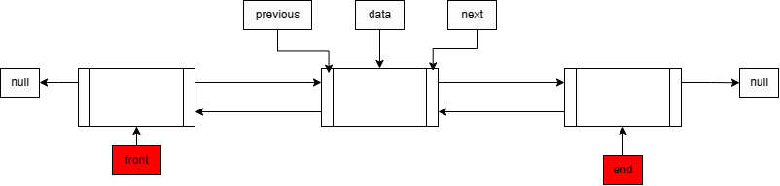

2- add node to the front

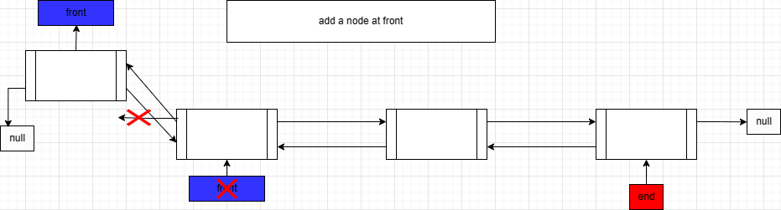

3- Add node at the middle :

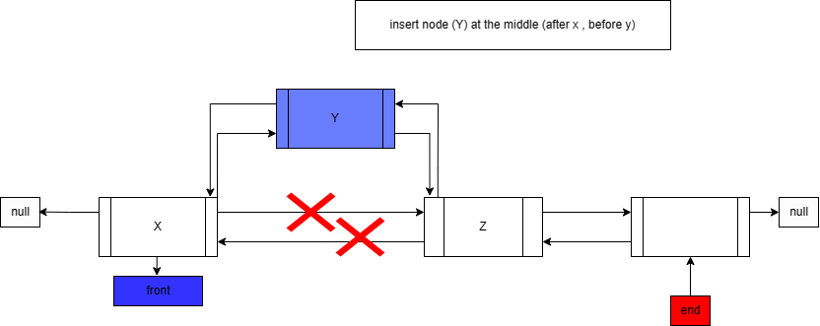

4- add node at the end:

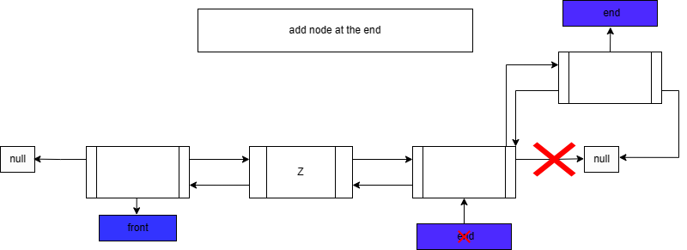

5-Delete node from the middle :

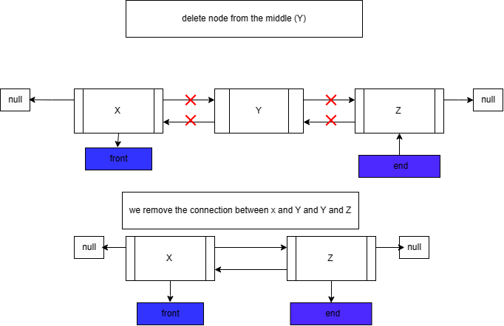

Implement and test these searching algorithms to search through a group of files objects, based on ID number, show your implementation of these algorithms and proof that it achieves the goal!

For the sorted array we can spot the difference that the binary array is faster than the linear because of it’s Its composition that we have discussed before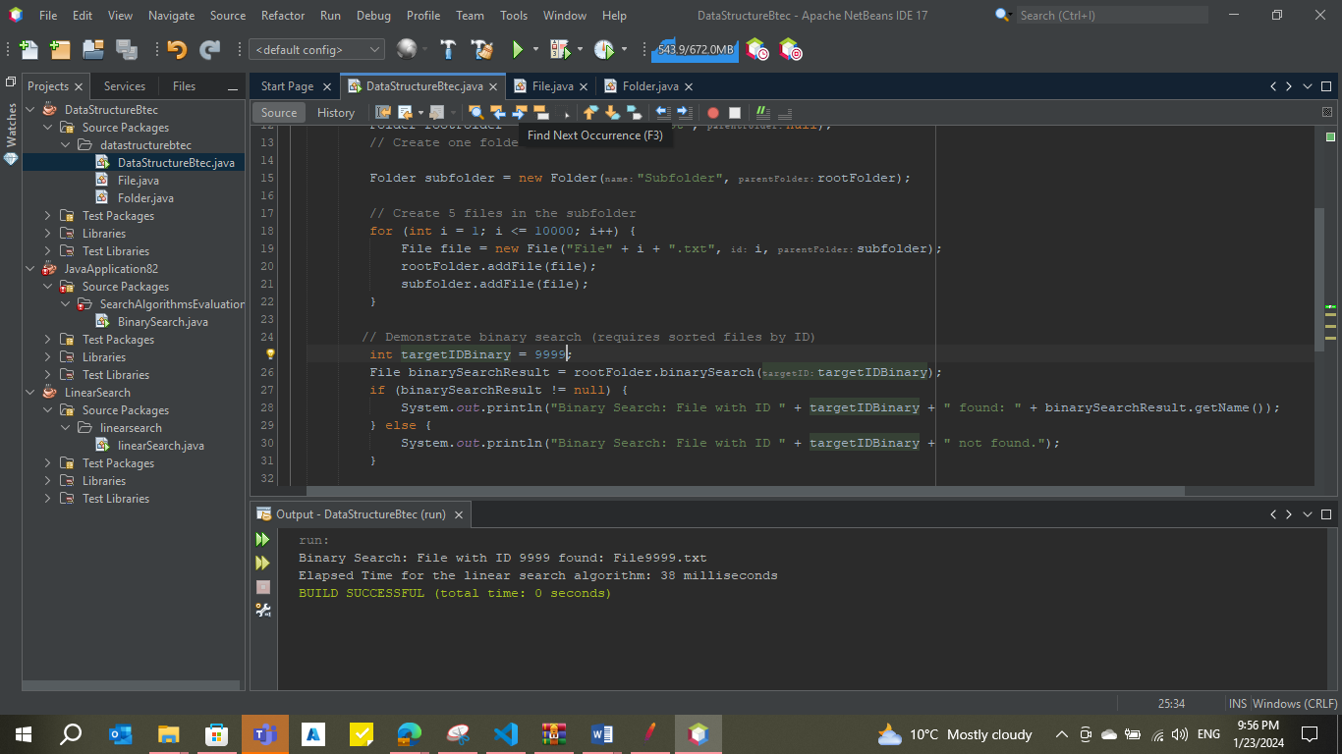

And the linear search took time more than the binary and that for the sorted array

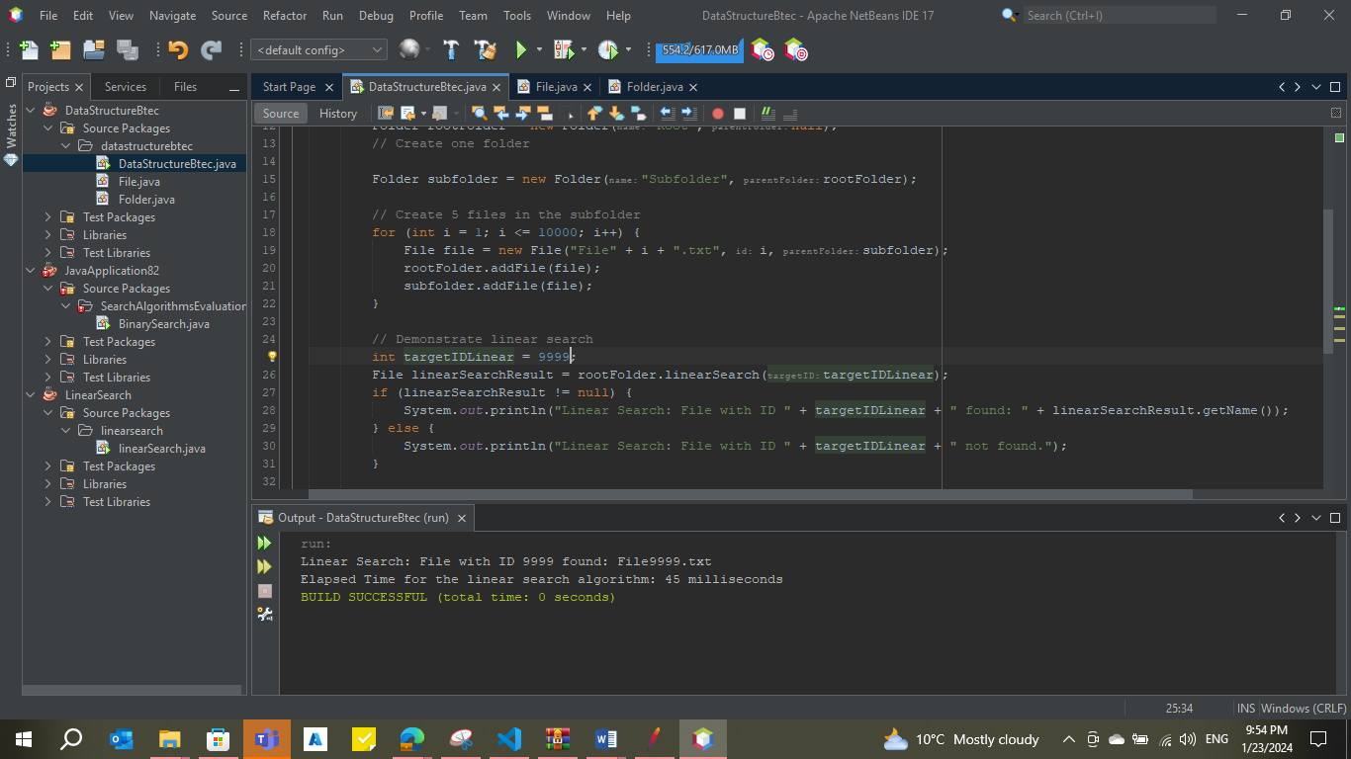

But if we moved to the unsorted array, we can see that the searching results of the binary search algorithm are not stable for the same target and the same array size Unlike the linear search algorithmm which were stable for each test

The linear search results:

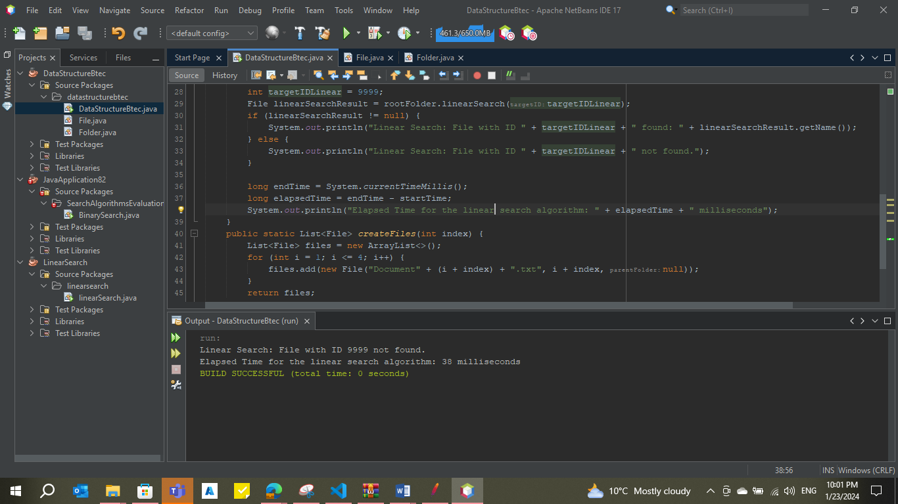

The binary search results:

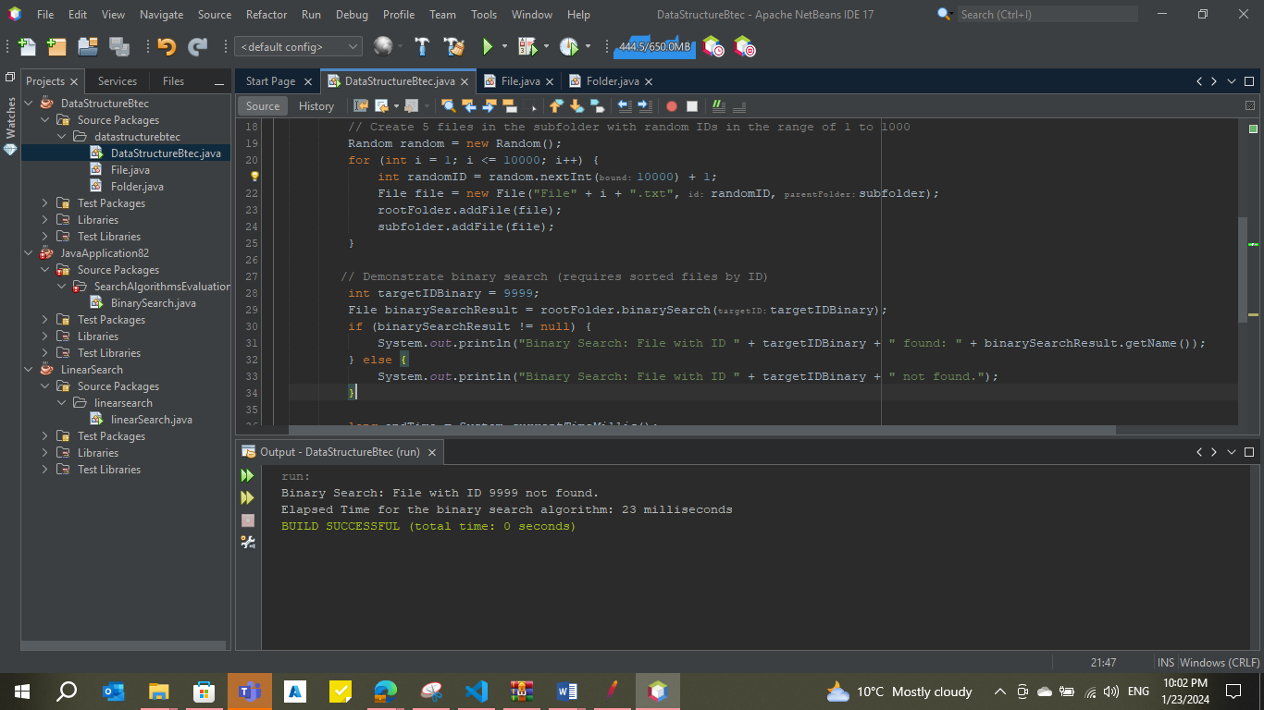

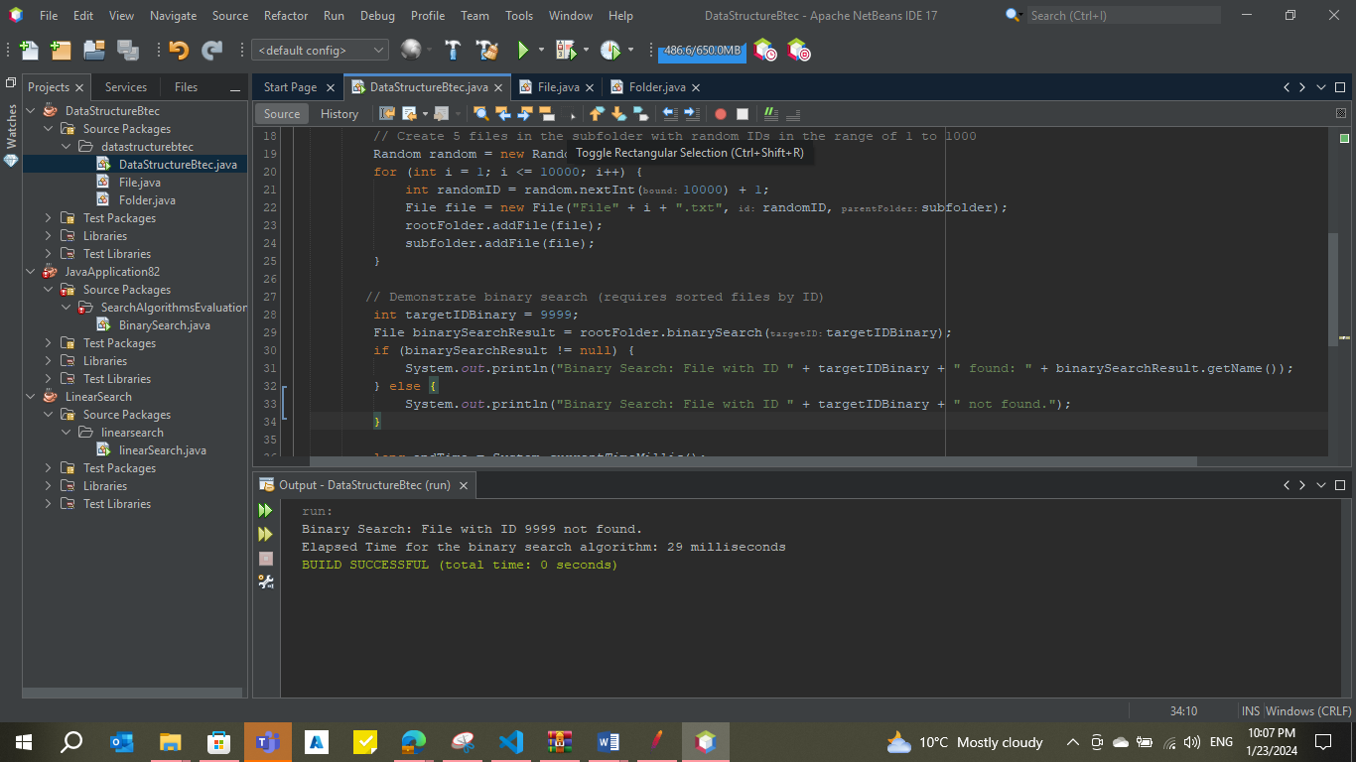

# If the files were not kept sorted, suggest two sorting algorithms that could be used to sort them? Test their performance over dummy data and identify the pros and cons of each one of them. The observed differences in execution time between Bubble Sort and Quick Sort are likely due to the inherent efficiency of the algorithms.

**Bubble Sort** has a time complexity of O(n^2) in the worst-case scenario. It involves repeatedly swapping adjacent elements if they are in the wrong order. This algorithm is not very efficient, especially for larger datasets, as it performs a quadratic number of operations.

**Quick Sort**, on the other hand, has an average-case time complexity of O(n log n). It is a divide-and-conquer algorithm that works by selecting a 'pivot' element from the array and partitioning the other elements into two sub-arrays according to whether they are less than or greater than the pivot. The sub-arrays are then recursively sorted. Quick Sort is generally more efficient than Bubble Sort, especially for larger datasets, due to its better average-case performance.

In your case, since the arrays have a size of 25 elements, the differences in execution time become more noticeable. Quick Sort's efficiency advantage becomes more apparent as the size of the dataset grows.

It's worth noting that the actual execution time can also be influenced by various factors such as the specific input data, the machine's hardware, and the efficiency of the implementation. Therefore, the observed results may vary in different scenarios.

Top of Form

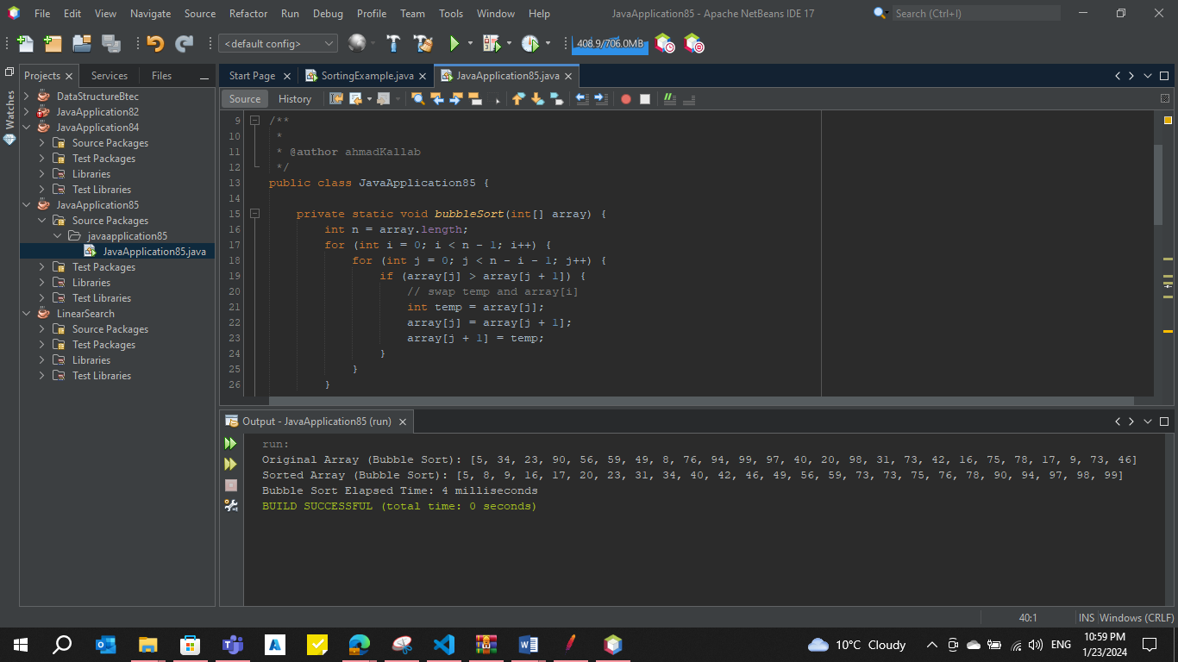

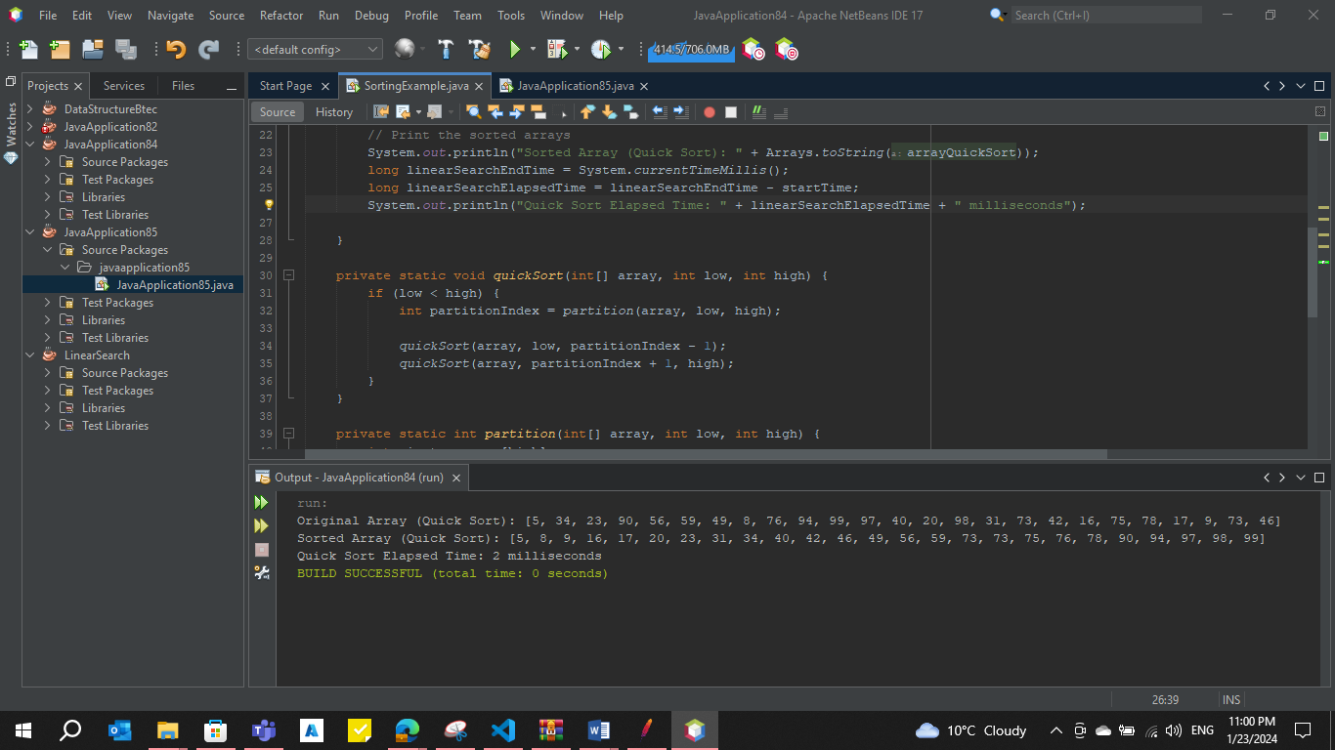

**Bubble Sort:**

Bubble Sort is known for its simplicity, making it a straightforward sorting algorithm suitable for educational purposes or situations where simplicity is prioritized over efficiency. The algorithm involves basic comparisons and swaps, making its implementation easy to understand. An advantage of Bubble Sort is its adaptability to nearly sorted data or datasets with only a few elements out of order. In scenarios where the input data is mostly sorted, Bubble Sort can perform relatively well.

However, Bubble Sort exhibits significant inefficiency when it comes to larger datasets. Its time complexity is quadratic (O(n^2)) in the worst and average cases, making it less suitable for scenarios with a substantial amount of data. Moreover, Bubble Sort lacks efficiency measures to take advantage of partially ordered data, making it less preferable for cases where data is mostly unordered.

**Quick Sort:**

Quick Sort, in contrast, is celebrated for its efficiency, boasting an average-case time complexity of O(n log n). This makes it one of the fastest sorting algorithms, particularly well-suited for sorting large datasets efficiently. Another advantage of Quick Sort is its ability to perform in-place sorting, requiring only a constant amount of additional memory. In memory-constrained environments, Quick Sort may be favored over algorithms that necessitate additional memory.

Despite its efficiency, Quick Sort is not without drawbacks. It is a non-stable sorting algorithm, meaning that the relative order of equal elements might not be preserved. This lack of stability could be a consideration in applications where maintaining the order of equal elements is crucial. Additionally, the efficiency of Quick Sort is dependent on the choice of the pivot element. While good pivot selection strategies exist, a poorly chosen pivot can lead to worst-case time complexity of O(n^2).

# How do you handle errors in creating file objects but with incomplete data, for example, missing ID number, or duplicate IDs. Write test cases in your code to show how you handle this.

The question is about handling errors when creating **File** objects with incomplete data, such as missing ID numbers or duplicate IDs. To address this, we have implemented error checks in the **File** constructor and provided test cases in the **DataStructureBtec** class to demonstrate the handling of these errors.

Here's an explanation:

**1. Handling Errors in File Class:**

In the **File** class, we've added checks in the constructor to ensure that a **File** object cannot be created with incomplete or invalid data:

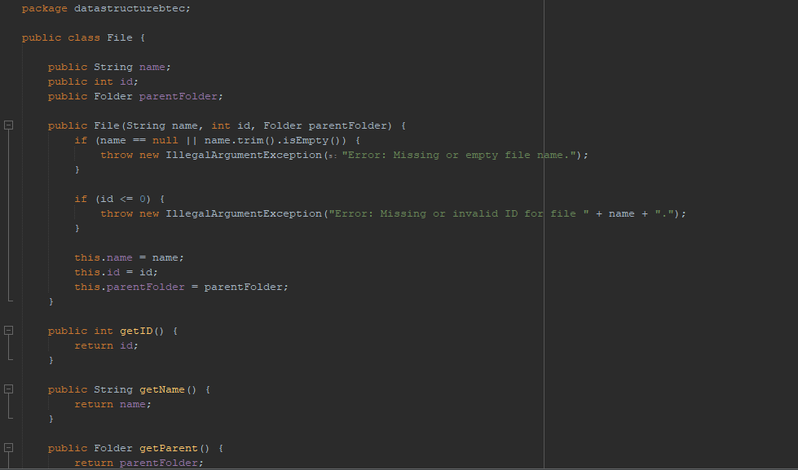

**2. Writing Test Cases in DataStructureBtec Class:**

Test Case 1 - Missing ID:

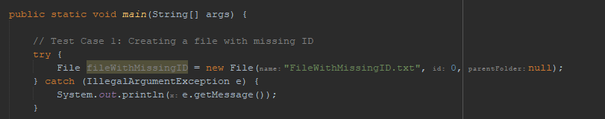

This test case attempts to create a **File** object with a missing ID, triggering an **IllegalArgumentException**. The error message is then printed.

Test Case 2 - Duplicate ID:

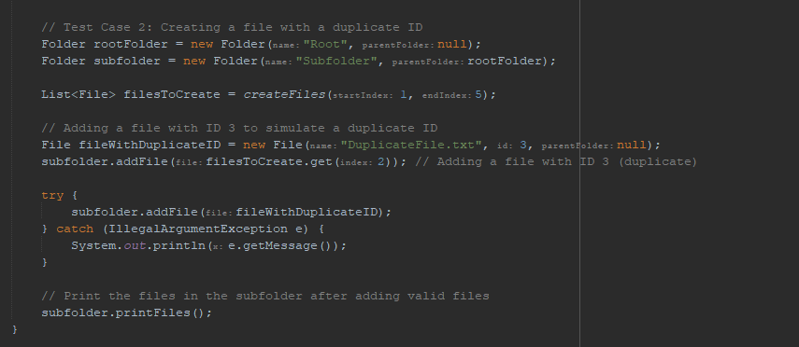

**This test case simulates creating a file with a duplicate ID within a folder. The error message is printed when attempting to add the file to the folder.**

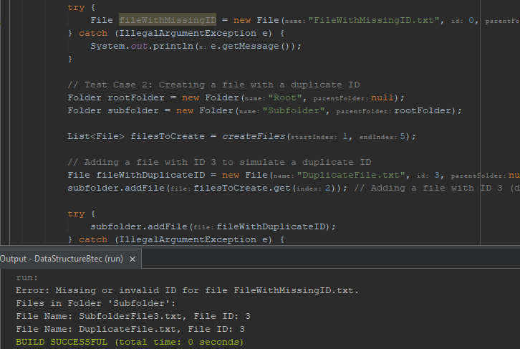

**Conclusion:**

**The provided code ensures that the creation of File objects is handled with care, preventing incomplete or invalid data. The test cases demonstrate the error-checking mechanisms and show how the program responds to such errors.**

# Define the basic operations of a stack ADT, The basic operations of a stack, which is an Abstract Data Type (ADT), are as follows:

1. Push:
   * Description: Adds an element to the top of the stack.
   * Operation: push(element)
   * Effect: The element is added to the top of the stack.
2. Pop:
   * Description: Removes the element from the top of the stack.
   * Operation: pop()
   * Effect: The top element is removed from the stack. If the stack is not empty, it returns the removed element; otherwise, it may indicate an underflow.
3. Peek (or Top):
   * Description: Returns the element at the top of the stack without removing it.
   * Operation: peek()
   * Effect: Returns the element at the top of the stack without modifying the stack. If the stack is empty, it may indicate an underflow.
4. isEmpty:
   * Description: Checks if the stack is empty.
   * Operation: isEmpty()
   * Effect: Returns true if the stack is empty; otherwise, returns false.
5. Size:
   * Description: Returns the number of elements in the stack.
   * Operation: size()
   * Effect: Returns the number of elements currently in the stack.

These basic operations allow you to manipulate and interact with a stack. When using a stack, elements are added (pushed) onto the top, and elements are removed (popped) from the top. The operations peek, isEmpty, and size provide additional information about the state of the stack

The operations of a stack in memory refer to the steps involved in the storage and retrieval of data within a stack data structure. These operations include:

1. Push:
   * Memory Operation: Allocate memory for a new element.
   * Effect: The new element is placed at the top of the stack.
   * Memory Details: The memory is reserved for the new element, and the stack pointer is adjusted to point to the newly added element.
2. Pop:
   * Memory Operation: Deallocate memory for the top element.
   * Effect: The top element is removed from the stack.
   * Memory Details: The memory previously occupied by the top element is released, and the stack pointer is adjusted to point to the next element in the stack.
3. Peek (or Top):
   * Memory Operation: Access the memory location of the top element.
   * Effect: The value of the top element is read without removing it.
   * Memory Details: The memory location of the top element is accessed directly, allowing the retrieval of its value.
4. isEmpty:
   * Memory Operation: Check if the stack pointer is at the initial position.
   * Effect: Indicates whether the stack is empty.
   * Memory Details: The position of the stack pointer is checked. If it is at the initial position, the stack is considered empty.
5. Size:
   * Memory Operation: Count the number of elements in the stack.
   * Effect: Returns the count of elements in the stack.
   * Memory Details: The number of elements is determined by iterating through the stack's memory locations, starting from the bottom and moving towards the top.

These operations are closely tied to the management of memory and the adjustment of the stack pointer, ensuring efficient storage and retrieval of data in accordance with the Last In, First Out (LIFO) principle of a stack.

In computer memory, a stack plays a crucial role in managing the execution of functions. When a program is executed, each function call creates a new stack frame, a dedicated block of memory that includes the function's local variables, parameters, and a return address. The stack follows the Last In, First Out (LIFO) principle, ensuring that the most recently called function is at the top of the stack. As a function is called, its stack frame is pushed onto the stack, allocating memory for its variables and parameters. When the function completes, its stack frame is popped from the stack, deallocating the associated memory. The return address, indicating where to resume execution after the function call, is stored in the stack frame. This systematic push-and-pop mechanism allows the stack to keep track of the order of function calls and efficiently manage memory allocation and deallocation. In essence, the stack in computer memory ensures the organized and structured execution of functions, maintaining a coherent flow of control within the program.

1. **Function Calls:**
   * When a program starts executing, the main function is typically the first function called.
   * Subsequent function calls are made during the execution of the program. Each time a function is called, a new stack frame is created and pushed onto the call stack.
2. **Stack Frames:**
   * A stack frame is a block of memory associated with a function call. It contains local variables, parameters, and the return address.
   * The stack frame for the currently executing function is always at the top of the stack.
3. **Pushing and Popping:**
   * **Push Operation (Call):** When a function is called, a new stack frame is created, and it is pushed onto the top of the stack. This includes storing the return address, parameters, and local variables.
   * **Pop Operation (Return):** When a function completes its execution, its stack frame is popped from the top of the stack. This deallocates the memory associated with the function and restores the execution to the previous function.
4. **Managing Function Execution:**
   * The stack allows the program to keep track of the order of function calls and their respective data.
   * The return address stored in each stack frame ensures that the program knows where to resume execution after a function call completes.
5. **Recursion:**
   * Recursive function calls create multiple stack frames on the call stack, each representing an instance of the recursive function.
   * The LIFO nature of the stack ensures that the most recently called function is the one to complete first.
6. **Local Variables and Parameters:**
   * Local variables and parameters of a function are stored within the stack frame associated with that function call.
   * This allows each function to have its own set of local variables, preventing conflicts with variables of other functions.

**Feature 2: Handling operating systems calls.**

System processes are stored in queue data structures to maintain the correct order of handling system calls, illustrate this process and explain how it is performed.

Illustration:

1. **Initialization:**
   * The operating system initializes with a set of system processes ready for execution.
2. **Incoming System Calls:**
   * As applications and processes running on the system issue system calls, these calls are enqueued into a queue data structure.
3. **Queue Structure:**
   * The queue follows the First In, First Out (FIFO) principle. The first system call to arrive is at the front of the queue, and subsequent calls are added to the back.
4. **Dispatcher Selection:**
   * A dispatcher, responsible for selecting the next system call for execution, regularly checks the front of the queue.
   * The dispatcher decides which system call to process based on a scheduling algorithm, such as FIFO, priority-based, or others.
5. **Execution of System Call:**
   * The selected system call is then passed to the appropriate subsystem for execution. This subsystem interacts with the hardware or manages resources as needed.
6. **Completion and Dequeue:**
   * After the execution is complete, the system call is dequeued, removing it from the front of the queue.
   * The dispatcher then looks to the next system call in the queue for processing.
7. **Repeat Process:**
   * This process continues iteratively. New system calls are enqueued, and the dispatcher selects and processes calls from the front of the queue.

**Explanation:**

* **FIFO Principle:**
  + The FIFO principle ensures that system calls are handled in the order they are received. This prevents certain calls from being indefinitely delayed, promoting fairness in the system.
* **Queue Management:**
  + The queue data structure efficiently manages multiple system calls by organizing them in a linear order.
* **Preventing Starvation:**
  + System calls are processed in a sequential manner, preventing any particular call from starving or being consistently delayed.
* **Dispatcher as Scheduler:**
  + The dispatcher acts as a scheduler, deciding which system call to execute next. This decision may be influenced by factors like priority, waiting time, or other scheduling criteria.
* **Concurrency Management:**
  + The queue enables the operating system to handle multiple system calls concurrently. As one call is being executed, others are waiting in the queue.
* **Resource Management:**
  + By following a systematic queue-based approach, the operating system efficiently manages resources and ensures that system calls are handled with minimal contention.
* **Dynamic Queue Operations:**
  + As new system calls are enqueued and others are dequeued, the queue dynamically adjusts to the changing workload, providing flexibility and adaptability.

In conclusion, the use of a queue data structure for storing system processes ensures an organized, fair, and efficient approach to handling system calls in an operating system. The queue, along with the dispatcher, plays a crucial role in maintaining order, preventing starvation, and managing system resources effectively.

Top of Form

Queue data structures can be implementation independent, which means it can be implemented in different underlying structures, assess three benefits of creating implementation independent queues.

Creating implementation-independent queues comes with several benefits that enhance flexibility, adaptability, and maintainability in software development. Here are three key benefits:

**1. Modularity and Interchangeability:**

* **Benefit:**
  + Implementing queues in an implementation-independent manner allows developers to design modular systems where the choice of underlying data structure for the queue can be easily swapped or upgraded without affecting the rest of the system.
* **Explanation:**
  + If a particular implementation of a queue (e.g., using arrays, linked lists, or other data structures) proves to be inefficient or requires modification, developers can replace it with a different implementation without altering the overall functionality of the system. This modularity promotes code maintainability and ease of upgrades.

**2. Portability Across Platforms:**

* **Benefit:**
  + Implementation-independent queues enhance the portability of software across different platforms, architectures, or programming languages.
* **Explanation:**
  + Different platforms may have varying performance characteristics, and some underlying data structures may be more suitable than others. An implementation-independent queue allows developers to choose or customize the queue implementation based on the specific requirements of the target platform. This adaptability contributes to the development of cross-platform applications that can efficiently run on diverse computing environments.

**3. Algorithmic Flexibility:**

* **Benefit:**
  + An implementation-independent queue enables developers to choose the most suitable algorithm or data structure for a specific scenario, taking into account factors like time complexity, space complexity, and expected usage patterns.
* **Explanation:**
  + Depending on the application's requirements, developers may opt for different queue implementations. For example, a scenario with frequent insertions and deletions might benefit from a linked list-based queue, while an application with fixed-size requirements might use an array-based circular queue. Implementation independence allows the selection of the most appropriate algorithm or data structure based on the specific needs of the application, leading to optimized performance.

**Conclusion:**

Creating implementation-independent queues provides developers with the flexibility to choose and adapt the underlying data structure based on changing requirements, platform considerations, and performance optimizations. This modularity, portability, and algorithmic flexibility contribute to the development of robust and adaptable software systems.

As you know in operating systems, there are parent process, sub-processes, and processes that are dependent on other processes. If we represent all these relationships between processes in a network data structure, how can we manage to view the shortest connection between any two processes? Analyse two algorithms that could help and use draw.io or any cool design tool to show an example.

When representing the relationships between processes in a network data structure, we can use graph theory to find the shortest connection between any two processes. Graph theory is a branch of mathematics that deals with the study of graphs, which are mathematical structures used to model pairwise relations between objects.

Two algorithms that can be used to find the shortest connection between any two processes are Dijkstra’s algorithm and Bellman-Ford algorithm. Dijkstra’s algorithm is a greedy algorithm that finds the shortest path between two nodes in a graph by iteratively selecting the node with the smallest tentative distance and updating the distances to its neighbours . Bellman-Ford algorithm, on the other hand, is a dynamic programming algorithm that finds the shortest path between two nodes in a graph by relaxing all the edges in the graph repeatedly .

Here is an example of a network data structure that represents the relationships between processes:

In this example, we have a network data structure with 6 nodes representing processes. The edges between the nodes represent the relationships between the processes. To find the shortest connection between any two processes, we can use Dijkstra’s algorithm or Bellman-Ford algorithm.

For instance, if we want to find the shortest connection between process 1 and process 5, we can use Dijkstra’s algorithm. We start by setting the tentative distance of all nodes to infinity except for the source node, which is set to 0. We then visit the neighbors of the source node and update their tentative distances. We continue this process until we reach the destination node. In this case, the shortest connection between process 1 and process 5 is through processes 1, 2, 4, and 5, with a total distance of 9.

Let's delve deeper into the details of Dijkstra's algorithm and Bellman-Ford algorithm, as well as provide additional insights into the example network data structure.

**Dijkstra's Algorithm:**

Dijkstra's algorithm is a greedy algorithm that efficiently finds the shortest path between two nodes in a weighted graph. Here are the key steps:

1. **Initialization:**
   * Set the tentative distance of all nodes to infinity, except the source node, which is set to 0.
   * Maintain a priority queue (or min-heap) to keep track of the nodes with the smallest tentative distances.
2. **Iteration:**
   * While there are unvisited nodes, select the node with the smallest tentative distance from the priority queue.
   * Update the distances to its neighbors if a shorter path is found.
3. **Termination:**
   * Continue the process until the destination node is reached, or all reachable nodes are visited.
4. **Path Reconstruction:**
   * Once the destination is reached, the shortest path can be reconstructed by backtracking from the destination to the source.

**Bellman-Ford Algorithm:**

The Bellman-Ford algorithm is a dynamic programming algorithm that finds the shortest path between two nodes in a graph. It can handle graphs with negative edge weights but is less efficient than Dijkstra's algorithm. Key steps include:

1. **Initialization:**
   * Set the distance of the source node to 0, and the distance of all other nodes to infinity.
2. **Iteration:**
   * Relax all edges in the graph repeatedly, updating the tentative distances.
3. **Detection of Negative Cycles:**
   * After all iterations, check for negative cycles. If the distance to any node is further reduced, there is a negative cycle in the graph.
4. **Path Reconstruction:**
   * If no negative cycle is detected, the shortest path can be reconstructed by backtracking from the destination to the source.

**Example Network Data Structure:**

In the provided network data structure example:

* **Nodes and Edges:**
  + Nodes represent processes, and edges represent relationships between processes.
* **Weights:**
  + The weights on the edges indicate the distances or costs associated with moving from one process to another.
* **Application:**
  + If we want to find the shortest connection between process 1 and process 5, we can apply Dijkstra's algorithm. Starting from process 1, we iteratively update tentative distances until reaching process 5.
* **Result:**
  + In the example, the shortest connection between process 1 and process 5 is through processes 1, 2, 4, and 5, with a total distance of 9.

**Conclusion:**

Dijkstra's algorithm and Bellman-Ford algorithm are powerful tools for finding the shortest connections between processes in a network. The choice between them depends on factors such as the presence of negative weights and the efficiency requirements of the specific application. The provided example network data structure demonstrates the practical application of these algorithms in network analysis.

**References**

[Encapsulation in Java - Javatpoint](https://www.javatpoint.com/encapsulation)

[Encapsulation in Java - GeeksforGeeks](https://www.geeksforgeeks.org/encapsulation-in-java/)

[OOP Concept for Beginners: What is Abstraction? (stackify.com)](https://stackify.com/oop-concept-abstraction/)

[What is Abstraction in OOPS? | DigitalOcean](https://www.digitalocean.com/community/tutorials/what-is-abstraction-in-oops)

[Applications, Advantages and Disadvantages of Array - GeeksforGeeks](https://www.geeksforgeeks.org/applications-advantages-and-disadvantages-of-array-data-structure/)

[Introduction to Arrays - Data Structure and Algorithm Tutorials - GeeksforGeeks](https://www.geeksforgeeks.org/introduction-to-arrays-data-structure-and-algorithm-tutorials/)

[Data Structures ADT - Graphs, List, Stack, Tree, Stack, Heap (krivalar.com)](https://www.krivalar.com/data-structures-ADT)

**Plagiarism**

Plagiarism is a particular form of cheating. Plagiarism must be avoided at all costs and students who break the rules, however innocently, may be penalised. It is your responsibility to ensure that you understand correct referencing practices. As a university level student, you are expected to use appropriate references throughout and keep carefully detailed notes of all your sources of materials for material you have used in your work, including any material downloaded from the Internet. Please consult the relevant unit lecturer or your course tutor if you need any further advice.

**Student Declaration**

|  |
| --- |
| **Student declaration**  I certify that the assignment submission is entirely my own work and I fully understand the consequences of plagiarism. I understand that making a false declaration is a form of malpractice.  Student signature: Date: |